**Preservation of cultural heritage: A comparison study of 3D modeling between laser scanning, depth image, and photogrammetry methods**

*Mohamad Haziq Bin Ahmad Yusri,*

*Centre of Postgraduate Studies, Universiti Teknologi MARA, Selangor, Malaysia*

*M. A. Johan*

*School of Mechanical Engineering, College of Engineering,*

*Universiti Teknologi MARA, Terengganu, Malaysia*

*M. H. M. Ramli\**

*Sports Engineering and Artificial Intelligence, College of Engineering,*

*Universiti Teknologi MARA, Selangor, Malaysia*

*Email: haniframli@uitm.edu.my*

ABSTRACT

*This paper presents a multi-technique approach for cultural heritage recording and documentation. The focal point of the study is to generate three-dimensional (3D) model representations of a physical object and use orthographic projection to document the design. Three main methods are used to generate a 3D object, which are laser, depth image, and photogrammetry. A comparison analysis is designed to evaluate each method accordingly. For evaluation purposes, a case study is designed where a scale model of a 25-cm-long famous historic Portuguese Indian Armada, the “Flor de la Mar” is used as a sample for generating 3D model records. The comparison analysis shows that the method of photogrammetry is superior in terms of details, precision, and visualization, while laser scanning and depth image methods are capable of previewing the data into point cloud but with less accuracy. The results show that the photogrammetry method achieves 97.6% of accuracy in terms of dimensions and shapes.*

**Keywords:** *Robot Operating System (ROS); Photogrammetry; 3D model; laser; depth camera; heritage*

**Introduction**

Traditional sailing vessels are part of the Terengganu cultural heritage and have been preserved to retain the history of the country and the ancestors in Malaysia. Due to their unique method of architectural and sculpture carving features, traditional sailing vessels make priceless contributions to the current and future generations. These features reflect the supremacy of the past generations in the maritime sector. However, the ship-craftsmen do not have any document about the schematic design or blueprint in representing the traditional sailing vessels. They sketch and plan the design on a piece of wood and walls in an irregular state. So, it is impossible to collect and record the design in the correct document. Therefore, to preserve traditional sailing vessels, hands-on measurements of structural elements using a laser measuring tool (LMT) and measuring tape (MT) are commonly used.

Obtaining geometric information from traditional sailing vessels using hands-on measurements requires a certain amount of time and may put someone in danger when measuring at higher locations. The size of the traditional sailing vessels is immense, so it is difficult to measure the mast height from the vessel’s deck and some of the targeted structural elements are blocked by other structural elements.

To overcome the limitations of conventional approaches, three different methods were considered in this study. The first method used is laser range scanner, which is Light Detection and Ranging (LiDAR) sensor that uses light in the form of pulse laser to measure distances. Over the past years, LiDAR has been used in the robotics sector to avoid obstacles that are in range. Linghui Sui et al. [1] designed an autonomous household cleaning robot using low-cost 2D LiDAR in a robot operating system (ROS) environment. The LiDAR collects surrounding data, while the cleaning robot was moving throughout the entire room and build a 2D map. LiDAR is also capable to create 3D mapping by making fine adjustments to it. J. Pena Queralta et al. [2] used multiple rotating 2D LiDARs to produce 3D world visualizations using ROS environment while Nicolás Llanos Neuta et al. [3] developed a 3D perception system robot using only single 2D LiDAR.

The second method used in this study is depth image, which is Microsoft Kinect that well known as a motion sensor add-on for X-box gaming consoles. Kinect can scan human motion and also capture depth images. Ratha Siv et al. [4] used Kinect version 2 to reconstruct the 3D human face and implement the Poisson surface method for noise removal. They set up the distance between Kinect and the person between 500mm and 700mm, and the scanned focus only on the face. The results showed a product of smooth surface of the 3D reconstructed face compared with the normal scanned without Poisson method.

For the last method, photogrammetry is used to reconstruct a 3D model for dimensional measurements of traditional sailing vessels. Fabrizio Ivan Apollonio et al. [5] constructed a 3D visualization of museums assets using a photogrammetry-based workflow. They proposed an automated combination of acquisition, based on mobile equipment and real-time rendering. Calibration for the photogrammetry application was conducted using two different devices, and four different targeted objects. The iPhone X and Nikon DS200 were used. Four different objects, including artifacts of porcupine fish, Horn d’Arturo’s Globe, Marsili Bust, and Heracles were investigated for quality and accuracy comparisons. The result for the smartphone camera (iPhone X) can reach high-quality results within a specific and adequate photogrammetric pipeline, which are practically identical to the SLR camera (Nikon DS200).

Although these methods from the previous studies for various applications showed a high potential, the application of reliable and accurate methods for scanning a specific object is still under development. [1], [2], [4], [5].

The goal of this study was to establish a rough orthographic projection as a blueprint that represents the traditional sailing vessels. The first part of this study involved determining which of these three methods are reliable for scanning the traditional sailing vessel. For evaluation purposes, a case study is designed where a scale model of a 25-cm-long famous historic Portuguese Indian Armada, the “Flor de la Mar” is used as a sample for generating 3D model records. The second part of this study was to measure the outer dimensions of structural members in the ship model from the successful method. The digital 3D model data obtained were then applied to a 3D Modeler program for the orthographic projection of the traditional sailing vessel.

**3D Scanning methods**

**Laser Scanning**

Time-of-flight (ToF) scanning utilizes a ToF concept in getting distance measurements of an object. The laser-based method employs a laser beam to demonstrate how pulses of light travel and return to their origin. This answers the question of how far away the object is.

The traditional sailing sailboat in the experiment is scanned using an RPLiDAR A2M8 LiDAR sensor. According to an investigation done by Xueyang Kang et al. [6], an RPLiDAR A2M8 is considered acceptable for three-dimensional mapping reconstruction. This LiDAR delivers adequate performance for indoor application within a range of 16 meters and 8000 samples per second. Figure 1 depicts the configuration of the proposed scanning system. A stepper motor and motor controller, a LiDAR sensor, and two microcontrollers are all part of the 3D scanner. The scanner’s main control board is a Raspberry Pi 4B, which runs the usual Robotic Operating System (ROS) for hosting 3D visualization programs. The stepper motor’s movement, on the other hand, is controlled by the Arduino Uno (microcontroller board). Figure 2 depicts the stepper motor’s back-and-forth movement in three dimensions.

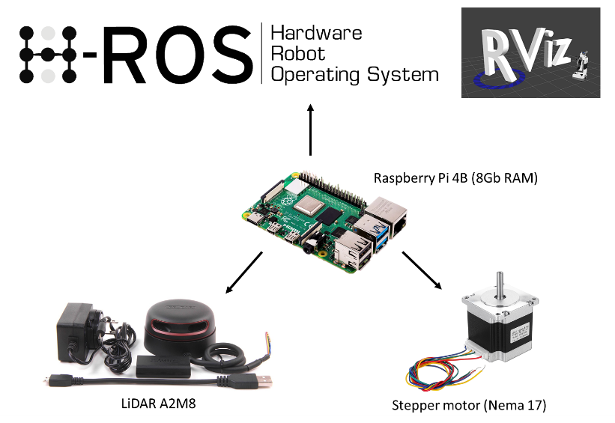

Figure 1: The components used during the experiment

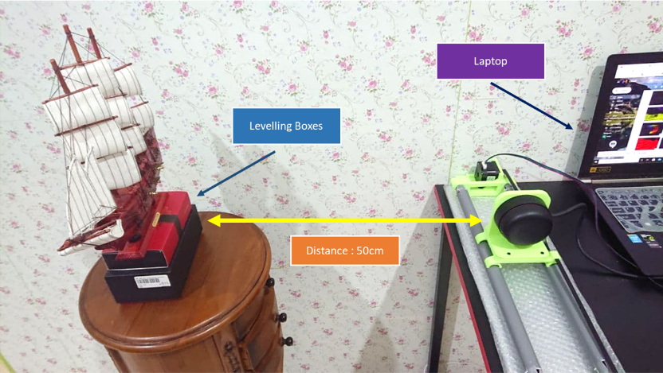

Figure 2: The proposed laser-based scanner setup

This method also was inspired by J. Pena Queralta et al. [2]; where three mounted LiDARs are used to obtain a 3D visualization of a designated room. Similarly, M. R. Shahrin et al. [7] generated a 3D map using an inexpensive 2D LiDAR sensor controlled by an Arduino Uno and moved by two servos. To increase scanning and plotting precision, the researchers employ a stepper motor rather than servos.



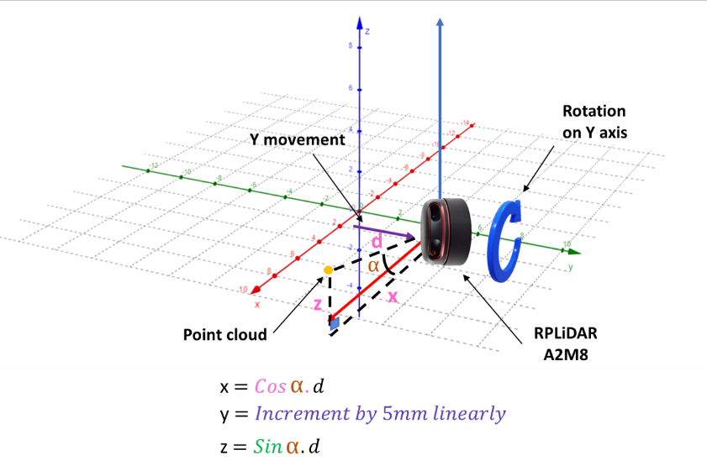

Figure 3: 3D space point cloud plot by the laser scanner

The Raspberry Pi 4B runs Ubuntu alongside the ROS Kinetic framework, giving it an excellent platform for 3D graphing scanned data with the ROS Visualization (RVIZ) plugin. The data in a 3D cartesian plane is plotted using Equation (1).

$x=\cos{α}.d$ (1a)

$y=linear incremental by 5mm$ (1b)

$z=\sin{α}.d$ (1c)

On RVIZ, Jing li et al. [8] and Juan Li et al. [9] developed a 3D semantic map building utilizing a combination of LiDAR and camera vision. They improved the data by combining each of them into a single point cloud, which resulted in increased accuracy and visibility over a larger scanning region. The LiDAR sensor and camera were tested individually for this study. The laser scanning procedure is depicted in Figure 3 as a flow chart.

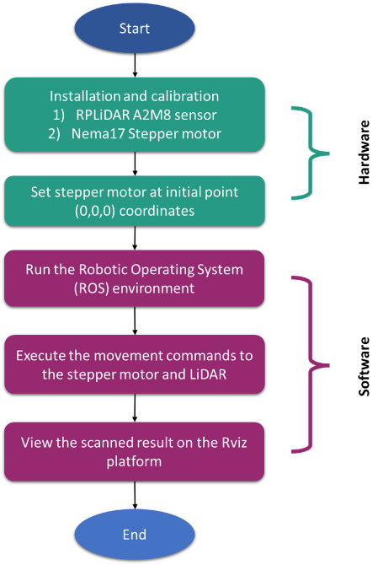

Figure 4: Laser scan process flow-chart

**Depth Camera Scanning**

A depth camera involves active 3D imaging sensor technology, characteristically capable of high measurement rates, producing several tens of images with depth information per second [10]. Depth cameras also utilize the ToF principle or structured light to scan a 3D object. Following the introduction of Microsoft Kinect, a large amount of research is stimulated because it combines the technology of RGB-D cameras, infrared projectors, detectors that mapped depth through ToF at a low price [11]. Kinect was quickly adopted by researchers as a means to further understand 3D data range in generating the virtual world. Some of the researchers use it to differentiate between living and non-living things by object recognition method [12].

In this study, Kinect V2 is used for 3D scanning experiments to evaluate the usability and quality of 3D scanning. There are two versions of Kinects which are Kinect V1 and Kinect V2. Kinect V1 has a camera of is 320 x 240, while Kinect v2 has improved to 512 x 424 at 30 frames per second (fps) and the maximum depth distance is 4.5 meters. M. Samir et al. [13] studied that the Kinect V2 stands out more than Kinect V1. That is why the Kinect V2 was chosen in this case study.

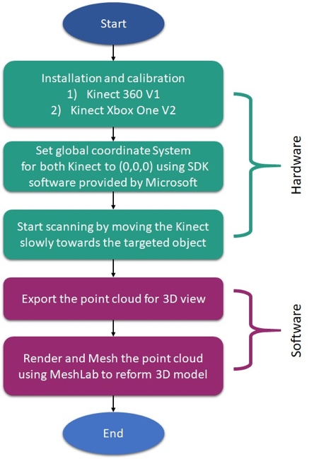

Figure 5: 3D scanning flowchart for a depth camera

The overall process flow is shown in Figure 4. The process starts with the installation and calibration of Kinect V2 via the provided Software Development Kit (SDK). Next is to initialize the global coordinate system and follow by scanning process. In the first scanning process, the Kinect will automatically set its coordinate system at the origin in 3 dimensions while capturing the depth image. Then, implement the Poisson surface method as shown by Ratha Siv et al. [4] on the reconstructed traditional sailing vessel. Once the scanning process is completed, 3D point cloud data is generated and converted into OBJ format for further processing. Finally, the OBJ data is processed using meshing software such as MeshLab to smoothen and harden the surface area of the 3D scanned object.

**Photogrammetry**

Digital photogrammetry is a technique to obtaining a 3D model by overlapping the captured two-dimensional (2D) images in measuring the size, shape, and 3D geometric position of an object. The principle of operation is based on the assigned point located on the images. The points connection needs to be at least two images that could create the 3D object coordinates. The 3D model quality improvement could be made by increasing the intersection numbers of assigned points. The above-mentioned process is proven to be effective as can be seen in [14] and [15].

It is pointed out that the camera position significantly affects the construction of the 3D model [16] where its position is dependent on the size and shape of the object. In addition, different types of camera selection yield different 3D model because each camera has dedicated pixels and focal length and sometimes adjustable.

In this experiment, smartphone Honor 9 Lite with 2 MP embedded with depth sensor and 26mm focal length are used to take pictures and generate 3D model via SFM based software. The overall process flow is shown in Figure 5. The process is quite simple because most of the processing and rendering efforts are done by the SFM software from calculating the point localization for each image, images orientation, depth images, and blur picture filtering and finally creating a precise 3D model. To generate a smooth surface 3D model, the lighting must be properly controlled during the task of taking pictures [17].

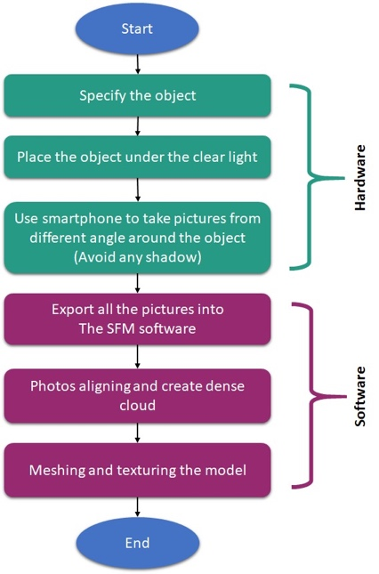

Figure 6: 3D modeling process using photogrammetry method

During the photography task the camera is set to a constant focal length i.e., without zooming as illustrated in Figure 6 and Figure 7. The first image is captured from the perpendicular direction of the object and denoted as *kth* position. The following position is *k+1th* until *k+nth*, with *n* being the total number of images required to generate the 3D model. The camera position and orientation can be calculated by eqns. (2)-(3) [18]. A further illustration of coordinate and orientation changes from position *kth* to *k+1th* is depicted in Figure 8.

Linear position in (X, Y, Z) coordinate

$X_{k+1}={X_{k}+(R}_{lx}-P_{lx})$ (2a)

$Y_{k+1}=Y_{k}+(R_{ly}-P_{ly})$ (2b)

$Z_{k+1}=Z_{k}+(R_{lz}-P_{lz})$ (2c)

Angular position in ($θ_{x}$, $θ_{y}$, $θ_{z}$)

$θ_{\left(k+1\right),x-axis}=θ_{k,x-axis}+θ_{x}$ (3a)

$θ_{\left(k+1\right),y-axis}=θ_{k,y-axis}+θ_{y}$ (3b)

$θ_{\left(k+1\right),z-axis}=θ_{k, z-axis}+θ_{z}$ (3c)

Where;

$R_{lx}$, $P_{lx}$ is the base length (m) at *kth* and *k+1th* position respectively, $R_{ly}$, $P_{ly}$ is the Mainmast height (m) at *kth* and *k+1th* position respectively, $R_{lz}$, $P_{lz}$ is Base depth (m) at *kth* and *k+1th* position respectively, $θ_{x}$ is angle difference between $R_{lx}$ and $P_{lx}$, $θ_{y}$ is angle difference between $R_{ly}$ and $P_{ly}$, and $θ_{z}$ is angle difference between $R_{lz}$ and $P_{lz}$.

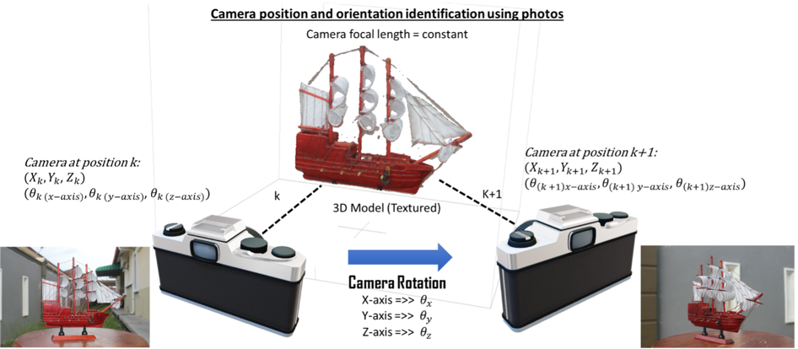

Figure 7: Illustration of photography scene at different angles and orientation

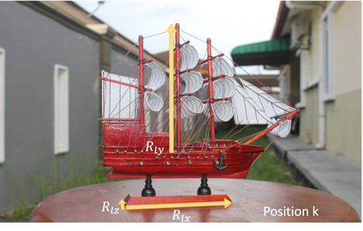

Figure 8: Camera view at (Left) *kth* position, (Right) *k+1th* position

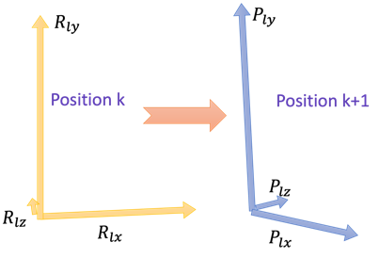

Figure 9: (Left) Illustration of the camera position at *kth* to *k+1th* in 3D space (Right) Orientation angles obtained from the position changes plotted on 3D space

**Results and Discussions**

This section provides the 3D scan result of each method. Evaluation of each method is properly carried out and also discussed in this section. To establish a unbiased comparison analysis, each method uses the same model.

c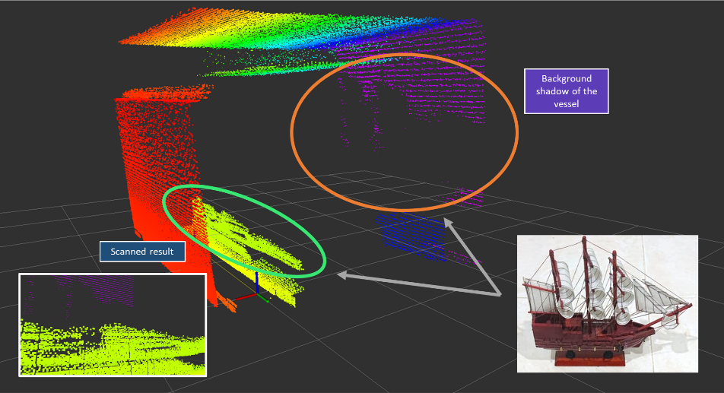

Figure 10: A view of 3D point cloud output of the sailing vessel model via RVIZ

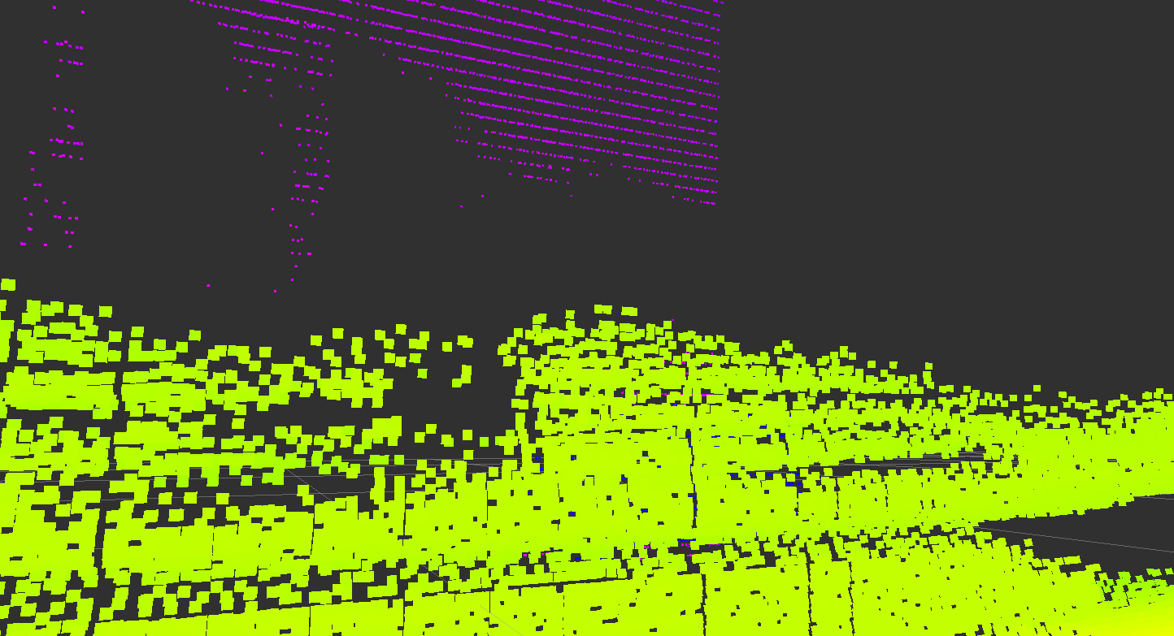

Figure 11: A closer look of the vessel point cloud

**Laser scanning method**

Figure 10 and Figure 11 show the 3D point cloud output of a sailing vessel in a room via laser scanning approach and processed in ROS environment using RVIZ platform. The variant colors of the point cloud represent the distance between RPLiDAR and the obstacles. The generated point cloud shown includes wall and roof but no view of the floor. The red point cloud is the nearest obstacle to the RPLiDAR during scanning and it indicates a wall, while the point cloud for the sailing vessel is greenish-yellow. It can be seen in Figure 10 and Figure 11 that the violet point cloud resembles the sailing vessel from the greenish-yellow point cloud. In a conclusion, the RPLiDAR has successfully scanned the traditional sailing vessel in the form of a point cloud, but it needs some more improvement to obtain higher accuracy and precision data.

**Depth Image method**

In the depth image method, Kinect V2 depth camera is used in the evaluation experiment. The result is shown in Figure 12.

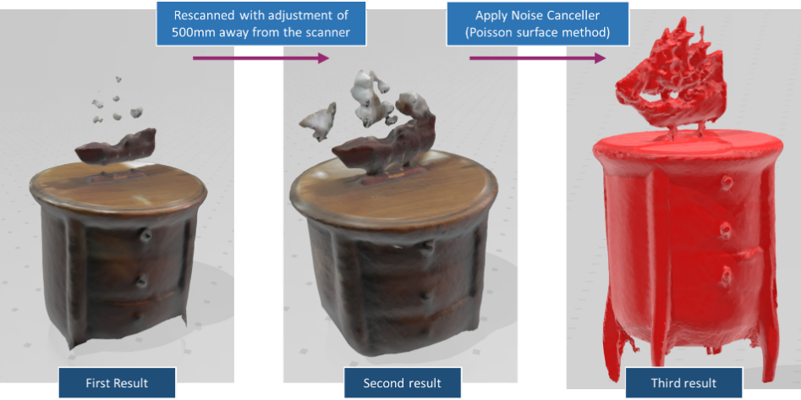

Figure 12: Workflow overview for the 3D scan using Kinect V2

It can be seen in Figure 12 that the traditional sailing vessel model is stationary on top of a small round table while scanning using Kinect V2. The first result shown is the complete scan with the distance parameter of 800mm between Kinect and model during scanning. Then for the second result, the Kinect was rescanned closer to the model with a distance of about 500mm between them. Lastly, the model was thoroughly re-examined and applied the noise canceller to create a better 3D model. Overall, the generated 3D model by Kinect V2 is much better compared to the first method. Nevertheless, the quality, accuracy, and precision are poor and could not be used for 3D model reconstruction of a physical object.

**Photogrammetry method**

A careful observation on the output, the photogrammetry method surpasses both laser and depth camera methods in terms of reconstruction quality, accuracy, and precision.

The same setup as the other methods has been used to scan the historic sailing vessel for the photogrammetry method. A total of 148 photos were taken at various angles to ensure all sides of the model are captured. In addition, Alignment and sequence of photography are carefully planned and sorted out to optimize the output of the 3D model. In this case, a circular photography method was applied in the anti-clockwise direction. Figure 13 shows the output of the 3D reconstruction model using Reality Capture Software.

Figure 13: 3D ship model result generated by Reality Capture software

To obtain the final result as shown in Figure 13, the captured photos undergo several processes. First, a method called scale-invariant feature transform (SIFT) is applied to match the correct position of imported images as depicted in Figure 14. In simple terms, SIFT is a feature detection algorithm in computer vision to detect and describe local features in images and then match the adjacent images to construct a correct 3D model. With this method, the SFM software can generate a dense point cloud by creating gradient lines on the picture and labeling the directions based on feature point localization from the image’s pixels. It has been used in a gamut of applications including object recognition, robotic mapping and navigation, image stitching, 3D modeling, gesture recognition, video tracking, and so forth, and proven to be effective [19]. The point cloud is then undergone a meshing process followed by the texture projection to construct a proper 3D model. These processes take some time to complete depending on the available computing power and resources. Lastly, the finished 3D model will be transferred to a Computer-Aided Design (CAD) software e.g., CATIA software for model finetuning, record keeping, and blueprint process.

Figure 14: The captured images are aligned according to SIFT algorithm

Analysis of Model Confidence Level

Figure 15 depicts a comparison between the physical model, the photogrammetric point cloud and the mesh model colored according to absolute deviation in percentage, one on the starboard (right) side and the other is on the port (left) side. The blue shaded color on the model represents the ideal value, which is about 80% to 100% confidence of measurements between the real object and the 3D model, followed by cyan color with 10% of confidence, green color (5% of confidence), and red shaded color with the estimated measurement of only 1% to become a true model. The greater the percentage values, the higher the accuracy to become a true model. Most of the red shaded colours are on the right side of the model and at the bottom of the sailcloth. This may be due to the excessive light and shadow during the photography session [20] because the images were taken in the afternoon at the open space area, with cloudy weather. Therefore, there are some surface areas that are blocked and covered with shadows that lead to errors in estimation. In addition, the thin white sailcloth may become transparent during the photo-taking process as the light passes through the sailcloth. The transparent object will reduce the percentage of accuracy drastically during the alignment of images and lead to the estimation of wrong values. Therefore, to reduce the percentage errors, points markers were used to help the SFM software identify the positions, orientations, and depth of the model in the images as illustrated in Figure 16. In this case, the alignment of images is focused on three main points 1, 2, and 3 which are an ultimate reference for the alignment using SIFT. Consequently, the confidence level increases as more reference points are introduced. However, it is a trade-off between computation time and confidence level.

Figure 15: A comparison of the photogrammetric point cloud and

mesh model colored according to absolute deviation in percentage, a) starboard side b) port side.

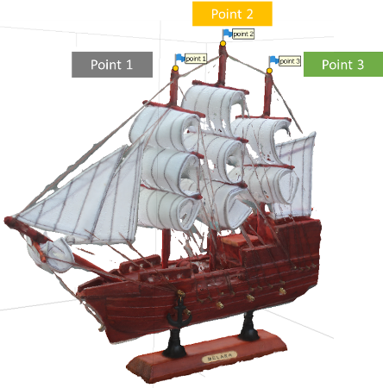

Figure 16: The alignment of images is focused on marked points using SIFT algorithm to increase the confidence level

Model Precision Analysis

Once the alignment of the pictures has been finalized, a polygonal model (structured data) is generated followed by texture to produce the best digital representation of the physical model. The produced model further fine-tuned to improve the state of the reconstructed 3D model. Therefore, the 3D model dimensions need to be evaluated and compared with the actual dimension of the physical model to justify that this method is effective to be used as one of the preservations and record documentation methods of objects.

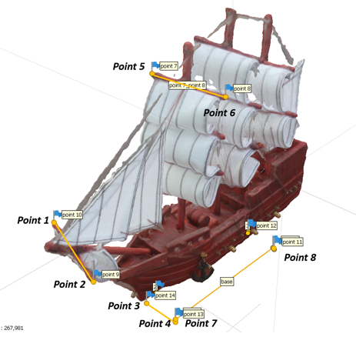

Figure 17: Marked points on the reconstructed 3D model to facilitate precision analysis

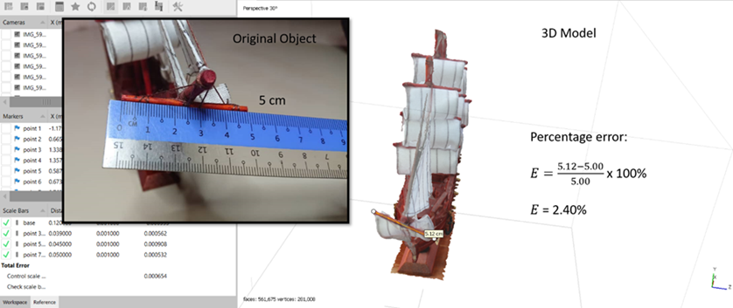

**5.12 cm**

Figure 17: Dimensions accuracy of the selected sections of the reconstructed 3D model

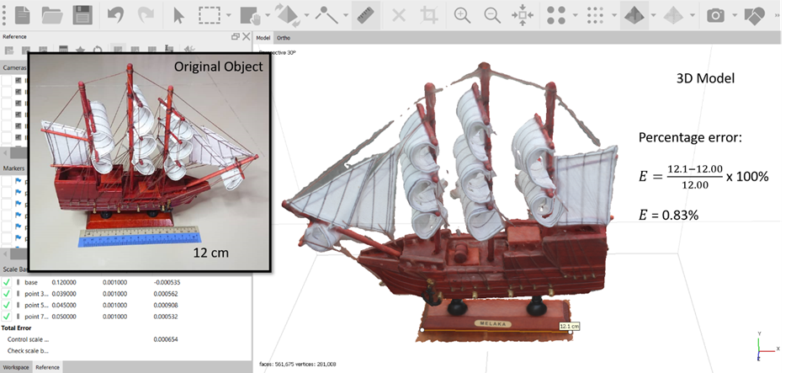

**12.1 cm**

Figure 18: Dimension accuracy of the selected sections of the reconstructed 3D model

Several points on the rebuilt 3D model have been highlighted to make studying model precision easier, as illustrated in Figure 16. The Sailcloth holder length (pt. 1 to pt. 2), Base Width (pt. 3 to pt. 4), Bowsprit length (pt. 5 to pt. 6), and Base length (pt. 7 to pt. 8) have all been identified as potential precision analysis possibilities.

Table 1: Percentage error between physical and 3D reconstructed models

|  |  |  |  |
| --- | --- | --- | --- |
| Part | Actual Dimension | Model Dimension | % Error |
| Sailcloth holder length | 5.00cm | 5.11cm | 2.20 |
| Bowsprit length | 5.00cm | 5.12cm | 2.40 |
| Base length | 12.00cm | 12.10cm | 0.83 |
| Base Width | 3.00cm | 3.05cm | 1.02 |

Table 1 displays tabulated statistics for % inaccuracy on selected areas of physical and 3D reconstructed models, identical to Figures 17 and 18. According to the measurement, the Base length has the lowest percentage inaccuracy, which is 0.83 percent. The bowsprit length, on the other hand, has the highest percentage inaccuracy at 2.40 percent of the entire length. Most of the time, the percentage of inaccuracy is around 1.6125 percent of the total. According to the percentage error numbers shown in the table, photogrammetry technology combined with SFM software can rebuild a high-quality and precise 3D model. As a result, the percentage of accuracy can be calculated by subtracting the greatest percentage error, 2.40 percent, from 100 percent and getting 97.6 percent.

SFM Software Performance: Reality Capture vs Agisoft Metashape

A total of 148 pictures were recorded and imported into two different processing platforms, Reality Capture and Agisoft Metashape software, to create the final output for the model of “Flor de la Mar”. When it comes to processing speed, Metashape is outperformed by Reality Capture. Metashape takes an average of 154 minutes, or nearly three hours, to complete all of the processes required to recreate the 3D model. Reality Capture, on the other hand, processes data in a fraction of the time it takes Metashape, taking an average of 74 minutes (about an hour) with identical settings and installations. As seen in Figure 19, Reality Capture surpasses Metashape in terms of output quality, delivering more details and fewer open holes than Metashape.

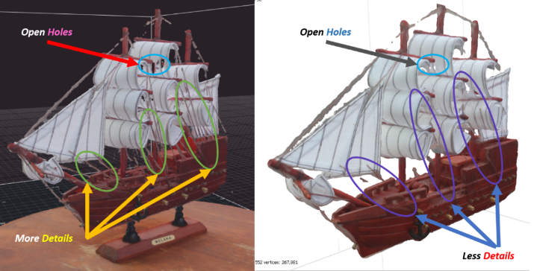

Figure 19: The comparison output result between Reality Capture (left) and Metashape (right).

Orthographic projection compilation

Finally, as illustrated in Figure 20, the successful 3D model is projected into an orthographic view for a basic documentation record. In terms of reconstruction quality, accuracy, and precision, the photogrammetry approach exceeds both laser and depth camera methods, as evidenced by a comprehensive study output.

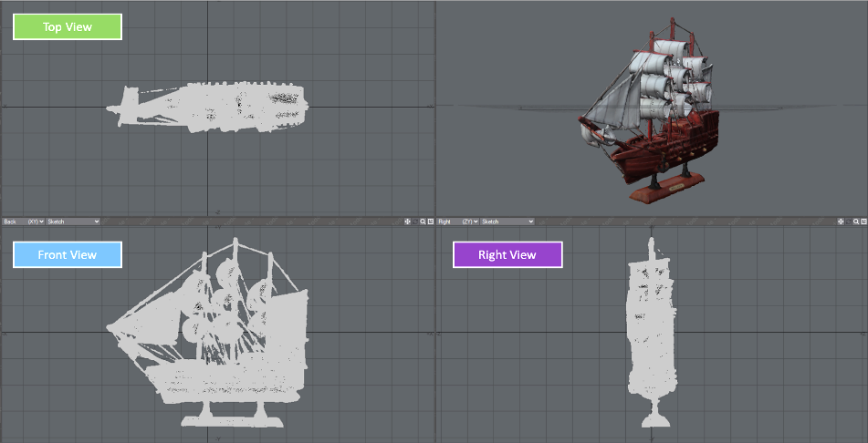

Figure 20: The orthographic projection of the “Flor de la Mar” model

**Conclusion**

This research examines the ability of laser scanning, depth camera, and photogrammetry approaches to aid in the digital reconstruction of three-dimensional (3D) models. According to the data, laser scanning is the least preferable approach for reconstructing a 3D model. The results of an experiment carried out using RPLiDAR A2M8 reveal that it is only capable of generating point clouds and is unable to construct 3D models. The 3D model created using the depth camera method is fairly rudimentary, with few surface details and warped portions. Kinect sensors, on the other hand, are light-sensitive and have a limited scanning area. The photogrammetry approach gives a good result with great precision in dimensions and excellent quality in 3D texture. This achievement will aid in the preservation of national heritages in the augmented reality environment, as well as provide a more realistic approach to developing future form design blueprints.

In terms of SFM software, i.e., photogrammetry post-processing Reality Capture exceeds Agisoft Metashape in two important areas: processing speed and output quality. Using the ship model as a test model, Reality Capture software is capable of scaling the model back to its original size, which is 1:1 scaled with precision and has a 97.6% accuracy rate.

**Acknowledgment**

This work is supported in part by the Ministry of Higher Education grant (Fundamental Research Grant Scheme).

**References**

[1] L. Sui and L. Lin, “Design of Household Cleaning Robot Based on Low-cost 2D LIDAR SLAM,” *2020 Int. Symp. Auton. Syst. ISAS 2020*, pp. 223–227, 2020, doi: 10.1109/ISAS49493.2020.9378863.

[2] J. P. Queralta *et al.*, “FPGA-based Architecture for a Low-Cost 3D Lidar Design and Implementation from Multiple Rotating 2D Lidars with ROS,” *Proc. IEEE Sensors*, vol. 2019-Octob, pp. 2019–2022, 2019, doi: 10.1109/SENSORS43011.2019.8956928.

[3] N. L. Neuta, S. A. Vivas, N. V. Fajardo, O. F. R. Giraldo, and V. R. Cano, “Low-cost recognition and classification system based on LIDAR sensors,” *2018 IEEE 2nd Colomb. Conf. Robot. Autom. CCRA 2018*, pp. 3–8, 2018, doi: 10.1109/CCRA.2018.8588139.

[4] R. Siv, I. Ardiyanto, and R. Hartanto, “3D human face reconstruction using depth sensor of Kinect 2,” *2018 Int. Conf. Inf. Commun. Technol. ICOIACT 2018*, vol. 2018-Janua, pp. 355–359, 2018, doi: 10.1109/ICOIACT.2018.8350702.

[5] F. I. Apollonio, F. Fantini, S. Garagnani, and M. Gaiani, “A photogrammetry-based workflow for the accurate 3d construction and visualization of museums assets,” *Remote Sens.*, vol. 13, no. 3, pp. 1–40, 2021, doi: 10.3390/rs13030486.

[6] X. Kang, S. Yin, and Y. Fen, “3D reconstruction assessment framework based on affordable 2D lidar,” *IEEE/ASME Int. Conf. Adv. Intell. Mechatronics, AIM*, vol. 2018-July, pp. 292–297, 2018, doi: 10.1109/AIM.2018.8452242.

[7] M. R. Shahrin, F. H. Hashim, W. M. D. W. Zaki, A. Hussain, and T. Raj, “3D indoor mapping system using 2D LiDAR sensor for drones,” *Int. J. Eng. Technol.*, vol. 7, no. 4, pp. 179–183, 2018, doi: 10.14419/ijet.v7i4.11.20797.

[8] J. Li, X. Zhang, J. Li, Y. Liu, and J. Wang, “Building and optimization of 3D semantic map based on Lidar and camera fusion,” *Neurocomputing*, vol. 409, pp. 394–407, 2020, doi: 10.1016/j.neucom.2020.06.004.

[9] J. Li, X. He, and J. Li, “2D LiDAR and camera fusion in 3D modeling of indoor environment,” *Proc. IEEE Natl. Aerosp. Electron. Conf. NAECON*, vol. 2016-March, pp. 379–383, 2016, doi: 10.1109/NAECON.2015.7443100.

[10] J. P. Virtanen, K. N. Antin, M. Kurkela, and H. Hyyppä, “The feasibility of using a low-cost depth camera for 3D scanning in mass customization,” *Open Eng.*, vol. 9, no. 1, pp. 450–458, 2019, doi: 10.1515/eng-2019-0056.

[11] H. L. L. Wellens, H. Hoskens, P. Claes, A. M. Kuijpers-Jagtman, and A. Ortega-Castrillón, “Three-dimensional facial capture using a custom-built photogrammetry setup: Design, performance, and cost,” *Am. J. Orthod. Dentofac. Orthop.*, vol. 158, no. 2, pp. 286–299, 2020, doi: 10.1016/j.ajodo.2020.01.016.

[12] Y. Zhang, T. Jia, Y. Chen, and Z. Tan, “A 3D Point Cloud Reconstruction Method,” *9th IEEE Int. Conf. Cyber Technol. Autom. Control Intell. Syst. CYBER 2019*, pp. 1310–1315, 2019, doi: 10.1109/CYBER46603.2019.9066630.

[13] M. Samir, E. Golkar, and A. A. A. Rahni, “Comparison between the KinectTM V1 and KinectTM V2 for respiratory motion tracking,” *IEEE 2015 Int. Conf. Signal Image Process. Appl. ICSIPA 2015 - Proc.*, pp. 150–155, 2016, doi: 10.1109/ICSIPA.2015.7412180.

[14] A. Tariq, S. M. O. A. Gillani, H. K. Qureshi, and I. Haneef, “Heritage preservation using aerial imagery from light weight low cost Unmanned Aerial Vehicle (UAV),” *Int. Conf. Commun. Technol. ComTech 2017*, pp. 201–205, 2017, doi: 10.1109/COMTECH.2017.8065774.

[15] I. Reljić and I. Dunder, “Application of photogrammetry in 3D scanning of physical objects,” *TEM J.*, vol. 8, no. 1, pp. 94–101, 2019, doi: 10.18421/TEM81-13.

[16] R. Pacheco-Ruiz, J. Adams, and F. Pedrotti, “4D modelling of low visibility Underwater Archaeological excavations using multi-source photogrammetry in the Bulgarian Black Sea,” *J. Archaeol. Sci.*, vol. 100, no. May, pp. 120–129, 2018, doi: 10.1016/j.jas.2018.10.005.

[17] H. El-Din Fawzy, “3D laser scanning and close-range photogrammetry for buildings documentation: A hybrid technique towards a better accuracy,” *Alexandria Eng. J.*, vol. 58, no. 4, pp. 1191–1204, 2019, doi: 10.1016/j.aej.2019.10.003.

[18] S. Yang, W. Jiang, and B. Tian, “ISAR image matching and 3D reconstruction based on improved SIFT method,” *Proc. - 2019 Int. Conf. Electron. Eng. Informatics, EEI 2019*, pp. 224–228, 2019, doi: 10.1109/EEI48997.2019.00056.

[19] H. El-Din Fawzy, “Study the accuracy of digital close range photogrammetry technique software as a measuring tool,” *Alexandria Eng. J.*, vol. 58, no. 1, pp. 171–179, 2019, doi: 10.1016/j.aej.2018.04.004.

[20] R. A. Galantucci and F. Fatiguso, “Advanced damage detection techniques in historical buildings using digital photogrammetry and 3D surface anlysis,” *J. Cult. Herit.*, vol. 36, pp. 51–62, 2019, doi: 10.1016/j.culher.2018.09.014.